
SYNOPSIS

Report on

Clarify-Image

By

PRASHANT GUPTA: Roll No: 2200290140113

Session: 2024-2025 (IV Semester)

Under the supervision of

MRS. KOMAL SALGOTRA (Teaching Assistant)

KIET GROUP OF INSTITUTIONS, DELHI-NCR, Ghaziabad

DEPARTMENT OF COMPUTER APPLICATIONS

KIET GROUP OF INSTITUTIONS, DELHINCR,

GHAZIABAD, 201206

(2024-2025)

Page 1 of 10

ABSTRACT

In the digital age of video content, Clarify-Image emerges as a pioneering photo editing platform, set to revolutionize the way we interact with and consume online media. It’s an evolution, designed to empower creators and engage audiences like never before.

Key Features:

1. Seamless photo Edit: Creators can effortlessly upload and share their photos, with support for various formats and resolutions.
2. Intelligent Recommendation Engine: clarify-Image cutting edge AI driven recommendation system ensures that users discover content tailored to their interests.
3. Enhanced Creator Tools: A comprehensive suite of creator tools, including analytics, monetization options, and audience engagement features, enables creators to thrive.
4. Community Building: Foster connections and engagement with your audience through edit the Image.
5. Adaptive Streaming: Enjoy smooth, buffer free playback with adaptive streaming technology.
6. Content Categories: Browse a vast array of content categories, from educational to entertainment, catering to a diverse audience.
7. Privacy and Safety: Robust content moderation and privacy settings ensure a safe and welcoming environment for all users.

Clarify-Image is not just about image editing, our vision is to empower content creators to unleash their creativity and connect with audiences worldwide. We believe that by providing a platform that prioritizes quality content, user engagement, and safety, we can elevate the image editing experience to new heights.

Page 2 of 10

CONTENTS

- Introduction Of Project

- Literature Review

- Objective Of the Project

- Research Methodology

- Project Outcome

- Proposed Time Duration

- References

Page 3 of 10
- INTRODUCTION

“Clarify-Image” contains all the tools you need for creating, editing, and retouching your images. It is friendly enough for the casual user who wants to enhance family photographs, yet powerful enough for the professional who needs to work with Images containing maps or with Image Processing or Artificial Intelligence.

Several features have been added to the “Image Processor” that helps in efficient processing of all kinds of Images.

Image Enhancement:

- Automatically adjust color balance, contrast, and saturation.

- Remove unnecessary noise from the Photograph using the Blur Tool.

- Sharpening Utility for sharpening blurred Images or Unclear Images.

- Edge Detection and Differentiation Utilities for detecting sharp edges in an Image.

- Adjustable Histogram enhances details without loss of information.

- Automatically improve image, scanned, and overly compressed images.

- Automatically remove noise, scratches, dust, or specks and improve crispness and impact.

- Negative Utility for converting the negative Images to its Positive Images.

- Converting a Color Image to a Grayscale Image.

- Utilities for Flipping the Image sideways or downwards.

- Shapes Utility for changing the shape of the Image to a Hexagon or a circle.

Therefore, Image Processor provides all the facilities that are required to effectively perform Image Processing.

Page 4 of 10
2. LITERATURE REVIEW

A literature review for a Clarify-Image project would involve summarizing relevant academic or industry research, articles, and studies related to Image Editing platforms, user behaviour, and technology. Here's a sample literature review section for your project:
1. Evolution of Image Editing Platforms
As these platforms have grown in popularity, they have become not just Quality Content but also educational and informational resources. Understanding this evolution provides valuable insights for developing a Clarify-Image that meets contemporary user expectations.
2. User Behaviour and Engagement on Image Editing Platform
Research into user behaviour on Image Editing platforms is pivotal in shaping platform design and content recommendations. For a Clarify-Image, optimizing user engagement mechanisms is essential for long term success.
3. Technological Advancements in Image Editing Platform
The advancement of Image Editing technologies has played a significant role in the user experience of Image Editing Platforms in particular, has become integral in delivering smooth playback experiences across various devices and network conditions. These technologies are essential components of any Clarify-Image aiming to deliver high quality Image.

In conclusion, a comprehensive review of literature in the field of Image Editing platforms provides essential insights for the development of a Clarify-Image.

Page 5 of 10
3. OBJECTIVE OF PROJECT

The objectives of a Clarify-Image project would depend on your specific goals and vision for the platform. However, here are some common objectives that you might consider when undertaking such a project:

1. Platform Development:
Create a functional and user friendly Image Editing platform that mimics the core features of Photo Editing Software.

2. Innovation and Differentiation:
Introduce unique and innovative features that set your Clarify-Image apart from the original platform, offering users something new and exciting.

3. User Engagement:
Foster a vibrant community of content creators and viewers by implementing engagement features like blending, Cutting, Cropping, and Adjust the Brightness Level.

4. Content Quality Control:
Implement content moderation and quality control measures to ensure that the platform is Compatible for all king of Images, free from Image content, and suitable for users.

5. Recommendation System:
Build an intelligent recommendation algorithm that helps users discover content tailored to their interests, enhancing user retention and engagement.

6. Scalability:
Design the platform to handle increasing user traffic and content uploads while maintaining performance and reliability.

7. Global Reach:
Aim to attract a diverse global audience by offering content in multiple languages and catering to various cultures and interests.

8. Creator Support:
Provide a comprehensive suite of tools and resources to support content creators, including analytics, copyright , protection, and promotional features.

9. Community Building:
Cultivate a sense of community among users and creators by facilitating interactions and collaborations.

10. User Education:
Educate users about responsible content creation and consumption, digital literacy, and online safety.

These objectives should align with your overall vision for the Clarify-Image and serve as a roadmap for its development and growth. Keep in mind that the success of your project will depend on your ability to execute these objectives effectively and adapt to evolving user needs and industry trends.

Page 6 of 10
4. Project Methodology

Creating a Clarify-Image is a complex project that involves multiple phases and tasks. Here's a step by step methodology to guide you through the development process:

1. Project Planning and Scope Definition:

Define Objectives: Clearly state the purpose and goals of your Clarify-Image project. Understand what you aim to achieve with this platform.

Target Audience: Identify your target audience and their preferences. Consider whether you are building the clone for a specific niche or a broader audience.

Scope: Determine the scope of your project, including the core features and functionalities you want to replicate from YouTube.

2. Market Research and Analysis:

Trends and Emerging Technologies: Stay updated on industry trends, emerging technologies, and user behaviour related to online video sharing.

3. Design and Architecture:

UI/UX Design: Design the user interface (UI) and user experience (UX) of your Clarify-Image. Create wireframes and mock ups to visualize the design.

4. Technology Stack Selection:

Choose the appropriate technologies and programming languages for both frontend and backend development, considering factors like scalability, security, and performance.

5. Testing and Quality Assurance:

Ensure cross browser and cross device compatibility.

6. User Education and Support:

Provide resources and support for users and content creators, including FAQs, and community forums.

Following this methodology will help you build a Clarify-Image that meets user expectations and industry standards while allow for flexibility and adaptability as the project progresses.

Page 7 of 10
5. Outcome of Project

The outcomes of a Clarify-Image project can vary depending on the goals and execution of the project. Here are some potential outcomes and benefits that you can expect from a successful Clarify-Image project:

1. User Engagement: With the right features and design, you can expect high user engagement. Users should be actively Edit the Images, commenting on images.
2. Community Building: Successful Clarify-Images foster the growth of a vibrant community of content creators and viewers who interact, collaborate, and form connections.
3. User Growth: As your platform gains popularity and users find value in it, you can expect continuous user growth, both in terms of content creators and viewers.
4. User Satisfaction: High user satisfaction, as evidenced by positive reviews, feedback, and user retention rates, is a key indicator of a successful Clarify-Image.
5. Innovation and Differentiation: Depending on your unique features and innovations, your project may stand out from other image-editing platforms, contributing to its success.
6. Continuous Improvement: Successful projects continue to evolve and improve based on user feedback and changing industry trends.

It's important to note that achieving these outcomes may take time and require ongoing effort. Building and maintaining a successful Image Editing platform is a significant undertaking, but with the right strategy, dedication, and user-focused approach, it can lead to a rewarding and impactful project.

Page 8 of 10
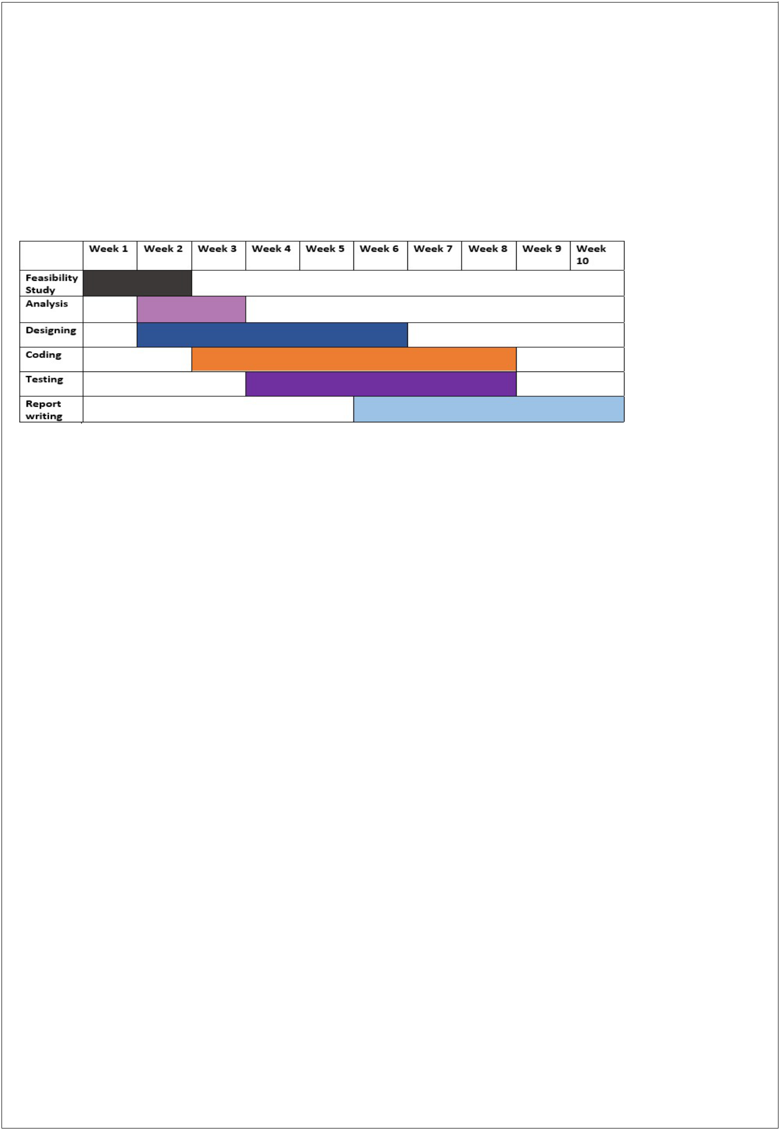
6. Proposed Time Duration

Gantt chart

Feasibility Study: We have decided 2 weeks for feasibility study and requirement gathering for that we can analysis our capabilities and resources.

Analysis: From 2 to 3 week, we proposed our self for esteem analysis of software requirements and risk and resource management.

Designing: In this phase (from 2 week to 6 week) we will focus on designing the blueprint of software and tries to focus on coding part also.

Coding: Form week 3" to week 8, we focus on coding part and tries to follow pre developed prototype of software.

Testing: Testing is not a part of only testing phase hence testing will be applied through each phase of software development life cycle.

Report Writing: During the process of developing project (software) we will constantly writes report on current project.

Hence the total time required to develop this project is around 10 weeks.

Page 9 of 10
7. References

Web Resources

www.w3schools.com

- Node JS Tutorials

- MongoDB Tutorials

BOOKS

Node JS The Complete Reference (7TH Edition)

By: Herbert Schildt

Oracle 10g

By: Ivan Baross

Software Engineering

By: Roger Pressman

Page 10 of 10

